1. Create the following page section using HTML and external CSS (no inline styles). Use a table or a definition list (in this case the layout will be different).  
     
   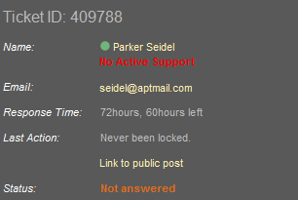
2. Create the following Web page using external CSS styles.   
     
   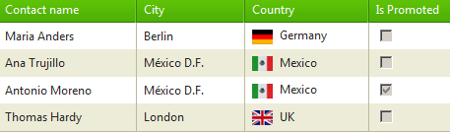
3. Create a web page using the   
   homework-3.png design and the HTML markup in homework-3.html.  
     
   